1. **Step 1. Fallout Risk**
   1. **Student: Oratile Personal unsecured loan at a fixed rate – Credit Card.**

|  |  |  |
| --- | --- | --- |
| SCENARIO | MODEL FAILURES | FINANCIAL CRISIS |
| 1 | Fraud detection that is ineffective:  To identify fraudulent transactions, credit card companies employ models. Failures of the model may lead to false positives, which infuriate customers, or false negatives, which result in financial losses by failing to identify fraud.  Improper Evaluation of Risk:  Credit card companies evaluate applicants' creditworthiness using predictive models. These models may fail if they evaluate an applicant's credit risk incorrectly. The model could approve high-risk applicants who are more likely to default, resulting in losses, if it undervalues the risk.  Financial Recessions:  Model failures can arise from financial crises and economic downturns because predictive models might not fully account for extreme events. In these circumstances, borrowers who, on the basis of past performance, were deemed low risk, might default because of unforeseen financial difficulties.  Model Diversion:  Due to shifting borrower behaviours, shifting market conditions, and other factors, model performance may deteriorate over time. To keep the accuracy of the model and avoid model drift, regular monitoring and updates are needed.  Overreliance on Historical Data:  In order to forecast future borrower behaviour, credit card lending models frequently rely on historical data. Model failures can occur when past data is not indicative of the state of the economy today or when the economy is changing quickly and previous data becomes less relevant.  Lack of Diversity in the Data:  When models are constructed using incomplete or skewed data, they may not accurately reflect the wide variety of borrowers and their credit behaviours. This may lead to prejudice against some groups or erroneous risk assessments.  Compliance with Regulations:  Model malfunctions may result from a failure to adhere to evolving regulatory standards. For the purpose of avoiding financial and legal repercussions, credit card lending models must abide by all applicable laws and regulations. | Financial Crisis:  The ability of credit card borrowers to maintain their financial stability can be severely impacted by economic downturns, such as recessions or financial crises. Increased credit card delinquencies and defaults may result from job losses, income reductions, and economic uncertainty.  High Debt Amounts:  Financial stocks are more likely to affect consumers who have large credit card debt accumulation. Debtors may find it challenging to make their payments on time if their debt-to-income ratio is high, particularly if interest rates increase or the economy deteriorates.  Interest rates are rising.  Borrowers may incur higher costs from credit card debt as interest rates rise. This may result in increased minimum payments, which some people may find difficult to fulfill, especially if they have credit cards with variable interest rates.  Overuse of Credit:  Debtors may be more likely to accrue debt that they find difficult to pay back when lenders grant credit cards with high credit limits or accept applications from applicants with poor creditworthiness. Credit overuse can result in defaults and losses for lenders.  Changes in Regulations:  The way that credit card loans are treated on bank balance sheets can be affected by changes in accounting standards or regulations, which can have an impact on the financial system's stability.  Insufficient Financial Literacy among Consumers:  Consumers' lack of financial literacy may be a factor in their credit card debt issues. People may abuse credit and rack up unmanageable debt when they are unaware of all the terms and implications associated with using credit cards. |

* 1. **Student: Oratile Personal unsecured loan at a floating rate – Car or Home Loan.**

|  |  |  |
| --- | --- | --- |
| SCENARIO | MODEL FAILURES | FINANCIAL CRISIS |
| 2 | Mistaken Risk Assessment: It is possible for models that evaluate borrowers' creditworthiness to miscalculate the chance of a loan default. Lenders may incur losses if they lend to high-risk borrowers who are more likely to default.  Overvaluation of Collateral: The value of the underlying property is frequently utilized as collateral for home loans. Exaggerated property values can lead to higher loan-to-value ratios and possibly greater default losses, which are indicative of model failures.  Economic Factors Underestimated: Models might not take changes in the state of the economy into sufficient account. For example, defaults on home and auto loans may increase during a recession. Higher-than-expected default rates may result from the models' failure to account for these changes in the economy.  Mistaken Assumptions: Mistakes can occur when models assume things like interest rates, borrower behaviour, or other important variables. Model failures may result from these assumptions not matching reality. One way to increase default rates is to assume a rising interest rate environment, but in reality, it can be declining or stable.  Lack of Data Diversification: Inaccurate results may be produced by models that rely on scant or skewed data. To produce accurate predictions, models must take into account a wide variety of variables and data sources.  Excessive Dependency on Credit Scores: Model failures may result from an excessive reliance on credit scores at the expense of other important variables such as employment history, income stability, and debt-to-income ratios. For other reasons, a borrower with a high credit score could nevertheless be considered a high credit risk.  Ignorance of Local Economic Factors: Borrowers' capacity to repay home and auto loans can be strongly impacted by local economic circumstances. Accurate credit risk assessment may be hampered by models that do not take these localized factors into account.  Inadequate Stress Testing: Model failures during unanticipated economic downturns or crises may result from a failure to stress-test models under different economic scenarios. To find out how the model will function in challenging circumstances, stress testing is crucial.  Insufficient Fraud Detection: To identify fraudulent loan applications or transactions, fraud detection models should be implemented for auto loans. When fraud goes undiscovered, model failures can lead to monetary losses.  Compliance Issues: The lending environment may be impacted by legislative and regulatory changes. Legal problems and monetary losses may arise if models do not adjust to new laws or compliance standards. | Home Loans: The Housing Market Bubble Burst.  The burst of a housing market bubble is a common catalyst for a financial crisis involving housing. This can occur when home values rise to an extreme point of overvaluation, and when the bubble bursts, home values may drop precipitously. Homeowners may consequently find themselves in default or face foreclosure due to underwater mortgages, which are mortgages that are greater than the value of the property.  Home Loans: Subprime Mortgage Crisis:  A famous example is the subprime mortgage crisis that occurred in the middle of the 2000s. Subprime mortgage loans were given by lenders to customers with bad credit records. Mass defaults by these borrowers affected banks, mortgage-backed securities, and eventually the overall economy as a whole, sending shockwaves through the financial system.  Interest rates on auto and home loans are rising:  Borrowers may find it more difficult to afford loan payments if interest rates significantly rise. This may result in greater default rates as well as more financial strain on borrowers in the case of variable-rate auto loans or adjustable-rate mortgages.  Poor Risk Assessment and Underwriting:  By using loose underwriting guidelines, lenders may give loans to people who aren't creditworthy. Lending institutions may suffer financial losses as a result of an increase in loan defaults.  Home loans and mortgage-backed securities are two examples of securitization.  Home loans packaged and sold as mortgage-backed securities can result in intricate financial products with unclear risks. The larger financial system may be impacted when these securities suffer large losses.  Home and auto loans are examples of speculative lending.  Lenders who engage in speculative lending practices, i.e., who lend money to borrowers who are likely to default, may suffer losses on their investments should defaults occur.  The recession that affects loans for cars and homes alike.  Borrowers may find it difficult to make their loan payments on cars or homes during economic downturns or recessions due to decreased income and job losses.  Auto Loans: Insufficient Diversification.  If financial institutions have a significant proportion of auto loans on their balance sheets, they may become overexposed to the auto lending market. If the market for auto loans declines, this could result in large losses.  Overextending Credit (Auto and Home Loans):  Overdraft customers run the risk of not being able to pay their bills on time. Loan defaults can result from excessive debt.  Regulation Modifications and Legal Concerns (Home and Auto Loans):  The lending climate may be impacted by modifications to laws or regulations. Legal troubles may result in financial penalties, while regulatory changes may result in stricter lending standards or new requirements. |

* 1. **Student: Ebenezer - Construction Business loan at a fixed rate**

|  |  |  |
| --- | --- | --- |
| SCENARIO | MODEL FAILURES | FINANCIAL CRISIS |
| 3 | * Model failures in this scenario can arise from inaccurate or flawed assumptions in the loan underwriting process. This includes the assessment of the borrower's creditworthiness and the feasibility of the construction project. A failure in assessing creditworthiness can increase the risk of default, while inaccuracies in project feasibility can lead to a higher risk of project failure. * Flawed modelling assumptions could also fail to account for potential cost overruns or delays in the construction project. These unforeseen challenges can impair the borrower's ability to repay the loan as expected. * Inaccurate estimations of construction costs and timelines, resulting from insufficient data or poor modelling techniques, can have severe repercussions. Overestimating costs or underestimating timelines can disrupt the project's financial viability, affecting the borrower's ability to service the loan. | * Economic downturns can significantly impact construction loans, as decreased demand for new projects can lead to reduced revenue. In such cases, borrowers may face difficulties in generating sufficient cash flow to meet their repayment obligations. * Natural disasters or unforeseen events that damage the construction site or completed project can lead to increased costs and delays. These unexpected events may strain the project budget and hinder the borrower's capacity to meet loan repayment commitments. * Financial crises can pose significant challenges. During such crises, there may be a decrease in demand for new construction projects, which could result in a decline in property values and an increased risk of default for borrowers. * A financial crisis can also lead to a tightening of credit markets, making it more difficult for businesses to secure financing for construction projects. The restricted access to credit markets exacerbates the challenges faced by borrowers, increasing the risk of loan defaults. |

* 1. **Student Yhasreen for bond and equity**

|  |  |  |  |  |
| --- | --- | --- | --- | --- |
| **Table 1.** | | | **Fallout Risk for Equity** | |
| **Analyst’s Consideration** | **Analyst’s Consideration** |
| **Model Failure** | **Financial Crisis** |
| **Security Lending Scenarios** | **4** | **AAPL**  **Equity Investment** | 1. **Parametric Instability:** Models often employ historical data to predict future performance. The parameter assumption needs constant revision due to the ever-changing nature of financial markets.   For example, economic conditions, technology shifts, and political landscapes fluctuate, causing a divergence between model predictions and actual performance.   1. **Liquidity Constraints:** Models do not adequately account for market liquidity, a significant determinant of an asset's trade ability. Inadequate liquidity modelling can result in larger-than-expected transaction costs and impede the successful execution of investment strategies. 2. **Model Overfitting:** The propensity for models to overfit, that is, tailored too closely to in-sample data, renders them less capable of generalizing their predictions to out-of-sample data. This phenomenon attenuates the model's predictive utility, thus potentially incurring financial losses. 3. **Non-linear Dynamics:** Equity markets often exhibit non-linear behaviors insusceptible to linear modelling techniques. Events such as market crashes, frequently described by "fat-tail" distributions, are not easily captured by conventional models, leading to unwarranted financial risk. 4. **Cognitive and Behavioral Biases:** Psychological factors such as overconfidence, herd behavior, and confirmation bias can affect traders' reactions to model outputs, undermining the integrity of the decision-making process. | 1. **Market Volatility:** Financial crises are characterized by extreme market volatility, exacerbating the difficulty of forecasting asset price movements. This heightened volatility impinges on short-term trading and long-term investment strategies, often leading to capital erosion. 2. **Liquidity Constraints:** During crises, liquidity evaporates, even for ostensibly liquid assets like AAPL. Liquidity risk can lead to an inability to execute orders at desired prices, incurring additional costs and potential losses. 3. **Credit Constraints:** The contraction of credit markets during financial crises can adversely affect individual and institutional investors, constraining investment capital and forcing deleveraging, even for investment in large-cap stocks like AAPL. 4. **Systematic Risk Amplification:** Financial crises often increase correlations among asset classes, including equities, thereby diminishing the efficacy of diversification as a risk mitigation strategy. 5. **Information Asymmetry:** In turbulent times, the paucityof reliable information and the preponderance of misinformation can exacerbate information asymmetry among market participants, further clouding investment decisions. 6. **Regulatory and Policy Uncertainty:** Financial crises often prompt legislative interventions, which could add a layer of regulatory uncertainty, affecting valuation models and investment strategies. |

* 1. **Student Yhasreen for bond and equity**

|  |  |  |  |  |
| --- | --- | --- | --- | --- |
| **Table 1.** | | | **Fallout Risk for Bond** | |
| **Analyst’s Consideration** | **Analyst’s Consideration** |
| **Model Failure** | **Financial Crisis** |
| **Security Lending Scenarios** | **5** | **2-year Treasury**  **Bond Investment** | 1. **Interest Rate Modeling Errors:** Quantitative models employed for interest rates are predicated upon assumptions that may not invariably hold, such as mean-reversion or constant volatility. Failures in these assumptions can lead to inaccurate yield curve forecasting, affecting investment decisions. 2. **Spread Risk Misestimation:** The spread between Treasury Bonds and other riskier fixed-income securities are improperly modelled. Erroneous assumptions regarding credit spreads can lead to inappropriate risk assessment and investment allocation. 3. **Macroeconomic Risk Factors:** Models often underestimate the impact of unforeseen macroeconomic variables such as fiscal policy changes or geopolitical events. The exogenous shocks emanating from such factors may induce substantial market volatility. 4. **Counterparty Risk:** While generally considered negligible for U.S. Treasury Bonds, counterparty risk can be mispriced in models under specific extreme scenarios like the default risk of the U.S. Government, although this is highly unlikely. 5. **Liquidity Risk:** Although 2-Year Treasury Bonds are highly liquid, models may fail to capture instances of reduced market liquidity, leading to higher transaction costs or inability to exit positions expediently. | 1. **Flight to safe-haven assets:** One of the most salient phenomena observed during financial crises is the "flight to safety," where investors disproportionately allocate capital to ostensibly low-risk assets like Treasury Bonds. While this appears beneficial, it suppresses yields and could create a bubble, leading to lower-than-expected returns. 2. **Liquidity Concerns:** Contrary to general expectations, even the liquidity of Treasury Bonds is compromised during severe financial crises, complicating trade execution and possibly incurring unanticipated transaction costs. 3. **Yield Curve Distortions:** Financial crises often result in policy interventions, such as Quantitative Easing, that could distort the yield curve. Misinterpretation of these distortions can lead to inaccurate risk and return assessments. 4. **Inflation Risk:** Financial crises, particularly those precipitated by economic contractions, may be followed by periods of high inflation due to aggressive fiscal and monetary policy actions. Such inflationary pressures can erode the real returns on fixed-income assets like Treasury Bonds. 5. **Policy Uncertainty:** Regulatory and monetary interventions during crises contribute to policy uncertainty, which could affect bond pricing and yield curve dynamics, complicating investment decisions. 6. **Reinvestment Risk:** The short maturity period of 2-year Treasury Bonds exposes investors to reinvestment risk, especially during financial crises when interest rates are subject to abrupt fluctuations due to central bank interventions. |

* 1. **Student: Ebenezer - An illiquid security – Real Estate Investment**

|  |  |  |
| --- | --- | --- |
| SCENARIO | MODEL FAILURES | FINANCIAL CRISIS |
| 3 | * Inaccurate Valuation Models: Model failures may arise from inaccurate or outdated valuation models for real estate properties. Real estate valuation relies on factors like market comps, income approaches, and cost-based assessments. Model failures could result from not properly accounting for local market dynamics, changes in zoning regulations, or property-specific factors. * Lack of Market Data: A challenge in modelling real estate investments is the lack of comprehensive and up-to-date market data. Models may fail if they rely on outdated or incomplete information, leading to misjudgements in property value and investment prospects. * Environmental and Regulatory Risks: Failure to consider environmental or regulatory risks, such as zoning changes, environmental contamination, or legal restrictions on property use, can lead to significant model failures. Failure to identify such risks may result in investments in properties with limited potential. * Liquidity Assumptions: Real estate investments are often illiquid. Model failures may occur when assumptions about the ability to sell or trade the investment are overly optimistic. Liquidity crises can arise when investors need to exit their positions but cannot do so without substantial losses. | * Economic Downturn: Real estate investments are sensitive to economic conditions. Financial crises, such as a recession, can lead to reduced property demand, falling rental income, and property devaluation. This impacts the income generated by the real estate investment, potentially leading to financial distress. * Interest Rate Fluctuations: Sharp increases in interest rates can increase borrowing costs for real estate investors. If not properly managed, this can strain finances and lead to defaults on real estate loans or challenges in refinancing existing mortgages. * Credit Market Tightening: During a financial crisis, credit markets may tighten, making it more difficult for real estate investors to secure financing for new investments or to refinance existing properties. This can lead to liquidity problems and difficulty in managing real estate portfolios. * Supply and Demand Imbalance: Financial crises can disrupt supply and demand dynamics in real estate markets. Overleveraged investors might face difficulties when demand drops, leading to difficulties in selling properties or leasing them at expected rates. |

1. **Step 2. Identifying Data Characteristics for Model Failure and Financial Crisis**
   1. **Student: Oratile Personal unsecured loan at a fixed rate – Credit Card.**

|  |  |  |  |  |  |
| --- | --- | --- | --- | --- | --- |
|  | | | **Data Characteristics Collection for Equity** | | |
| **CREDIT CARD LOAN** | **1** | **CREDIT CARD LOANS** | **1** | **Data type** | 1. Economic data 2. Assets |
| **2** | **Data preprocessing** | 1. Aggregated computing 2. Raw Prices 3. Levels |
| **3** | **Data frequency** | 1. Quarterly 2. Monthly 3. Annually |
| **4** | **Data class** | 1. Equity 2. Credit |
| **5** | **Data source** | 1. Regulatory authorities 2. Credit card companies 3. Credit burue 4. Financial institutions |
| **6** | **Data Variety** | 1. Account balance 2. Credit limits 3. Payment history |

* 1. **Student: Oratile Personal unsecured loan at a floating rate – Car or Home Loan.**

|  |  |  |  |  |  |
| --- | --- | --- | --- | --- | --- |
| **Table 3.** | | | **Data Characteristics Collection for Equity** | | |
| **HOME OR AUTOMOBILE LOANS** | **2** | **HOME OR AUTOMOBILE LOANS** | **1** | **Data type** | 1. Economic 2. Asset |
| **2** | **Data preprocessing** | 1. Unprocessed raw data 2. Percent 3. Levels |
| **3** | **Data frequency** | 1. Annual 2. Monthly 3. Quarterly |
| **4** | **Data class** | 1. Macro economics 2. Real estate 3. Consumer finance |
| **5** | **Data source** | 1. FRED <https://stlouisfed.org/series/> 2. Mortgage lenders 3. Real estate database |
| **6** | **Data Variety** | 1. Estimated, unadjusted data 2. Housing markets indices 3. Property valuers 4. Loan to ratios |

* 1. **Student: Ebenezer - Construction Business loan at a fixed rate**

|  |  |  |  |  |  |
| --- | --- | --- | --- | --- | --- |
| **Table 3.** | | | **Data Characteristics Construction Business loan** | | |
| **Scenario** | **2** | **Money at a fixed rate for a business for a construction loan** | **1** | **Data type** | 1. Credit |
| **2** | **Data preprocessing** | 1. Categories: credit rating |
| **3** | **Data frequency** | 1. Quarterly 2. Semi-Annually |
| **4** | **Data class** | 1. Renovation 2. Construction |
| **5** | **Data source** | 1. Construction Companies 2. Credit Agencies |
| **6** | **Data Variety** | 1. Loan 2. Duration 3. Ratings |

* 1. **Student Yhasreen for bond and equity**

|  |  |  |  |  |  |
| --- | --- | --- | --- | --- | --- |
| **Table 2.** | | | **Data Characteristics/ Collection for Equity** | | |
| **Security Lending Scenarios** | **4** | **AAPL**  **Equity**  **Investment** | **1** | **Data type** | 1. Numerical: Interest rates, inflation rates, GDP growth, consumer confidence index, employment rates. 2. Categorical: Regulatory changes, credit ratings, market sectors. 3. Temporal: Time series data related to interest rates, market indices, and economic cycles. |
| **2** | **Data preprocessing** | 1. Normalization: Adjusting all variables to a common scale. 2. Imputation: Filling missing values using statistical techniques. 3. Transformation: Log or square root transformations to handle skewed data. 4. Seasonal Adjustment: For metrics like employment data or quarterly GDP figures. |
| **3** | **Data frequency** | 1. High Frequency: Intraday stock prices for equity investments. 2. Monthly: Consumer credit data, interest rates. 3. Quarterly: GDP growth, corporate earnings. 4. Annually: Regulatory changes, inflation rate, employment data. |
| **4** | **Data class** | 1. Structured: Standardized numerical data such as yields and interest rates. 2. Unstructured: Textual data like news articles or Federal Reserve minutes. 3. Time-Series: Chronologically ordered data like bond yields and interest rates over time. |
| **5** | **Data source** | 1. Government Publications: Data from the Federal Reserve, Bureau of Labor Statistics, U.S. Treasury. 2. Financial Exchanges: Data from stock exchanges like NYSE or NASDAQ. 3. Credit Bureaus: For credit ratings and default rates. 4. Market Research Firms: Consumer confidence index, market sentiment indicators. |
| **6** | **Data variety** | 1. Cross-sectional Data: Data captured at a single point in time,   useful for snapshots of credit card default rates or market capitalization.   1. Longitudinal Data: Data collected over multiple time points, useful for analyzing trends in interest rates or stock prices. 2. Big Data: Large volumes of transactional data for credit card usage or trade volumes in equities. |

* 1. **Student Yhasreen for bond and equity**

|  |  |  |  |  |  |
| --- | --- | --- | --- | --- | --- |
| **Table 2.** | | | **Data Characteristics/ Collection for Bond** | | |
| **Security Lending Scenarios** | **5** | **2-year**  **Treasury**  **Bond**  **Investment** | **1** | **Data type** | 1. Numerical: Interest rates, inflation rates, employment rates, GDP growth. 2. Categorical: Credit ratings, bond ratings, monetary policy decisions. 3. Temporal: Time series data related to yield curves, credit default rates. |
| **2** | **Data preprocessing** | 1. Normalization: Ensuring all numerical variables are comparable. 2. Imputation: Handling missing data via statistical methods. 3. Transformation: Managing skewed data through log or square root transformations. 4. Seasonal Adjustment: Adjusting for seasonality in economic metrics such as employment data. |
| **3** | **Data frequency** | 1. Daily: 2-year Treasury bond yields. 2. Monthly: Federal Funds rates, consumer credit data. 3. Quarterly: GDP figures, corporate default rates. 4. Annually: Inflation data, monetary policy reports. |
| **4** | **Data class** | 1. Structured: Standardized numerical data such as yields and interest rates. 2. Unstructured: Textual data like tweets from social media, news articles or Federal Reserve minutes. 3. Time-Series: Chronologically ordered data like bond yields and interest rates over time. |
| **5** | **Data source** | 1. Government Institutions: Federal Reserve, U.S. Treasury, Bureau of Labor Statistics. 2. Credit Rating Agencies: Moody’s, Standard & Poor’s. 3. Financial News Outlets: For qualitative data such as market sentiment. |
| **6** | **Data variety** | 1. Cross-sectional Data: Data captured at a single point, useful for comparative analyses. 2. Longitudinal Data: Data collected over multiple time periods, ideal for trend analysis. 3. Big Data: Voluminous transactional data relevant for market depth or credit utilization patterns. |

* 1. **Student: Ebenezer - Illiquid Security Investment**

|  |  |  |  |  |  |
| --- | --- | --- | --- | --- | --- |
| **Table 3.** | | | **Data Characteristics Collection for Real Estate Investment** | | |
| **Scenario** | **6** | **An illiquid security – Real Estate Investment** | **1** | **Data type** | 1. Real Estate Market Data |
| **2** | **Data preprocessing** | 1. Historical Prices |
| **3** | **Data frequency** | 1. Daily 2. Intraday 3. Weekly |
| **4** | **Data class** | 1. Real Estate |
| **5** | **Data source** | 1. Stock Market |
| **6** | **Data Variety** | 1. Actual Prices 2. Valuation 3. Funding |

1. **Step 3. Ethical Consideration and Its Undesirable Results Based on Model and Crisis Fallout Risk**
   1. **Student: Oratile Personal unsecured loan at a fixed rate – Credit Card.**

|  |  |  |
| --- | --- | --- |
| SCENARIO | ETHICAL CHALLENGES | UNDESIRABLE RESULTS |
| 1 | High-Interest Rates and Fees: Credit card companies often charge high-interest rates and fees, especially to individuals with lower credit scores. This can lead to concerns about the ethics of profiting from individuals who may be financially vulnerable.  Unsolicited Credit Card Offers: The practice of sending unsolicited credit card offers, especially to individuals who may not have the financial means to manage credit responsibly, can be seen as ethically questionable.  Credit Limit Increases: Automatically increasing a cardholder's credit limit without their request can lead to excessive debt accumulation. Some consumers may view this practice as unethical because it encourages overspending.  Credit Scoring and Discrimination: The use of credit scoring models can sometimes result in discrimination against certain demographic groups, as these models may unfairly disadvantage individuals based on factors beyond their control, such as race, gender, or age.  High Penalties for Late Payments: Some credit card companies impose steep penalties and increased interest rates for late payments. These high fees can be seen as punitive and potentially exploitative, especially for individuals who face financial difficulties.  Data Privacy and Security: Credit card companies are custodians of sensitive financial data. Ensuring the ethical treatment and protection of this data is crucial to maintaining trust with consumers. | Accumulation of Debt: One of the most common undesirable outcomes is the accumulation of high-interest debt. Credit cards often have high annual percentage rates (APRs), and when cardholders carry a balance from month to month, interest charges can quickly add up, making it challenging to pay down the debt.  High Interest Costs: Credit card interest rates can be significantly higher than other forms of borrowing, such as personal loans or mortgages. Cardholders who carry a balance end up paying substantial interest charges, which can make credit card debt very expensive over time.  Overdraft Fees: Overusing a credit card, especially when there isn't enough money in the associated bank account to cover the payment, can result in overdraft fees and other bank charges.  Impact on Retirement Savings: Using credit cards to finance expenses can divert funds away from retirement savings. Instead of building wealth for the future, individuals may find themselves focusing on debt repayment.  Compromised Financial Goals: High credit card debt can hinder individuals from achieving their financial goals, such as homeownership, starting a business, or pursuing higher education.  Loss of Assets: In cases of severe delinquency or default, credit card issuers may take legal action to collect the debt, which could result in the seizure of assets or legal judgments.  Bankruptcy: Extreme cases of credit card debt can lead to personal bankruptcy, which has long-term financial and legal consequences.  Limited Access to Emergency Funds: If an individual's credit card is already heavily utilized, it may not be available as an emergency source of funds during unexpected financial crises. |

* 1. **Student: Oratile Personal unsecured loan at a floating rate – Car or Home Loan.**

|  |  |  |
| --- | --- | --- |
| SCENARIO | ETHICAL CHALLENGES | UNDESIRABLE RESULTS |
| 2 | Predatory lending practices involve taking advantage of vulnerable borrowers by offering them loans with exorbitant interest rates, hidden fees, and unfavourable terms. These practices can lead to financial distress and hardship for borrowers and are widely regarded as unethical.  Discrimination:  Lenders must adhere to anti-discrimination laws, such as the Fair Housing Act and the Equal Credit Opportunity Act. Discriminatory practices in lending, such as redlining (denying loans based on the racial or ethnic composition of a neighbourhood) or gender-based discrimination, are unethical and illegal.  Hidden Fees and Misleading Terms:  Failing to provide clear and transparent information about loan terms, including fees and interest rates, can be considered unethical. Borrowers have a right to understand the true cost of their loans before making financial commitments.  Inadequate Risk Assessment:  When lenders approve loans for borrowers who are unlikely to repay, it raises ethical concerns. This can lead to financial hardships for borrowers and potential economic instability.  Lack of Fair Access to Credit:  Unequal access to credit based on socioeconomic factors or geographic location can be considered an ethical challenge. All borrowers should have a fair opportunity to access loans.  Conflicts of Interest:  Financial institutions may face ethical challenges when they prioritize their own profits over the best interests of borrowers. This includes steering borrowers toward loans that generate higher fees or commissions for the lender.  Environmental Impact (Auto Loans):  The ethical concerns surrounding auto loans may also include considerations of environmental impact. Lenders providing financing for vehicles with poor fuel efficiency or those contributing to air pollution can face ethical dilemmas.  Responsible Repossession (Auto Loans):  In the case of auto loans, repossessing vehicles from borrowers in financial distress must be done ethically and legally. Unfair or aggressive repossession practices are seen as unethical. | Financial Distress: Taking on excessive debt through home or automobile loans can lead to financial stress and potential insolvency. High monthly payments and interest costs may strain a borrower's budget.  Asset Repossession: In the case of automobile loans, non-payment can result in the repossession of the vehicle. For home loans, non-payment can lead to foreclosure, resulting in the loss of the borrower's home.  Accumulation of Interest Costs: The interest paid over the life of a loan can substantially increase the overall cost of the asset. This can lead to borrowers paying much more than the original purchase price.  Negative Equity: In certain circumstances, borrowers may owe more on their loans than the assets are worth. This is known as being "underwater" and can make it difficult to sell the asset or refinance the loan.  Reduced Credit Score: Missed or late payments can negatively impact a borrower's credit score, making it more difficult to access credit in the future and potentially leading to higher interest rates on other loans.  Loan Defaults: Loan defaults can result in financial losses for lenders, who may need to write off the loans as nonperforming assets, impacting their profitability.  Operational Costs: Managing loans, particularly delinquent ones, can incur operational costs for lenders in terms of collections, legal proceedings, and servicing.  Financial System Risk: A high level of bad loans in the financial system can undermine the stability of banks and other lending institutions, potentially requiring government intervention to stabilize the financial system. |

* 1. **Student: Ebenezer - Construction Business loan at a fixed rate**

|  |  |  |
| --- | --- | --- |
| SCENARIO | ETHICAL CHALLENGES | UNDESIRABLE RESULTS |
| 3 | * Transparency and Disclosure: Lenders might face ethical dilemmas related to transparency. When offering construction loans to businesses, they must provide clear and comprehensive information about the terms, risks, and obligations associated with the loan. Failure to do so can be seen as unethical. * Fair Assessment: Ethical concerns may arise when assessing the creditworthiness of businesses seeking construction loans. Lenders must ensure that their evaluation methods are impartial and free from any biases or discriminatory practices. * Responsible Lending: Lenders should adhere to principles of responsible lending, making sure that the borrower has the means to complete the construction project. Failing to do so may lead to unethical lending practices. | * Misallocation of Capital: If construction loans are granted without proper due diligence, it can lead to the misallocation of capital. Businesses may receive loans they cannot repay, resulting in financial distress. * Business Failures: The undesirable result may include an increased rate of business failures if construction projects funded by loans do not yield the expected returns. * Economic Instability: The cumulative effect of unethical lending and the resulting undesirable outcomes can lead to economic instability, particularly if a significant number of construction projects fail. |

* 1. **Student Yhasreen for bond and equity**

|  |  |  |  |  |
| --- | --- | --- | --- | --- |
| **Table 3.** | | | **Ethical Consideration on Model and Crisis Fallout Risk for Equity** | |
| **Analyst’s Consideration** | **Analyst’s Consideration** |
| **Model Failure** | **Financial Crisis** |
| **Security Lending Scenarios** | **4** | **AAPL**  **Equity Investment** | 1. **Misrepresentation and Lack of Transparency:** Financial models often rely on historical data and specific assumptions. Failure to accurately represent these elements or to make transparent the model's limitations can lead to ethical quandaries regarding the veracity and integrity of investment advice. 2. **Agency Problems:** Model failures can exacerbate agency problems if fund managers or financial advisors focus on their short-term incentives at the expense of their clients' long-term welfare, potentially constituting a breach of fiduciary duty. 3. **Distributive Justice:** Model failures can lead to significant financial losses, raising concerns about the equitable distribution of investment risks and returns. Less sophisticated investors may suffer disproportionately, raising ethical questions about social equity and justice. 4. **Information Asymmetry and Exploitation:** Flawed models may perpetuate or exacerbate information asymmetry, creating opportunities for exploitation by market participants with superior information or more robust models. 5. **Ethical Hazard in Algorithmic Trading:** If models employed in algorithmic trading fail, they may lead to unintended market manipulations. Failed algorithms create an ethical dilemma regarding accountability for such manipulative practices. | 1. **Financial Bailout** exacerbates model hazard.: During financial crises, interventions such as bailouts or unconventional monetary policies may engender a moral hazard among investors, fostering a culture of excessive risk-taking under the presumption of external support. 2. **Information Asymmetry:** Financial crises often exacerbate information disparities, engendering exploitation and predation of less-informed investors. Ethically, this raises questions about fair market practices. 3. **Agency Problems and Fiduciary Duties:** In a crisis environment, the alignment between the financial interests of investors and those of financial advisors or fund managers can be discordant, thereby raising ethical issues about the proper execution of fiduciary duties. 4. **Manipulative Practices:** Financial crises often witness increased market volatility and liquidity constraints, ripe for manipulative practices such as short-selling or "pump and dump" schemes. These activities raise ethical concerns about market integrity. 5. **Economic Inequality:** The high volatility and unpredictability during crises can disproportionately affect retail investors and exacerbate economic inequalities. Volatility invokes ethical concerns around social justice and wealth distribution. 6. **Transparency and Disclosure:** Firms are tempted to obscure their financial conditions during crises. A lack of transparency can create ethical dilemmas related to investor trust and corporate responsibility. |

* 1. **Student Yhasreen for bond and equity**

|  |  |  |  |  |
| --- | --- | --- | --- | --- |
| **Table 3.** | | | **Ethical Consideration on Model and Crisis Fallout Risk for Bond** | |
| **Analyst’s Consideration** | **Analyst’s Consideration** |
| **Model Failure** | **Financial Crisis** |
| **Security Lending Scenarios** | **4** | **2 Year Treasury Bond**  **Investment** | 1. **Moral Hazard:** Misguided risk assessment due to model failure may engender a moral hazard where investors, imbued with false confidence, take undue risk with the presumption of safety in Treasury bonds. 2. **Fiduciary Misalignment:** Model failure can exacerbate conflicts of interest between financial advisors and their clients. An advisor may prioritize instruments that yield higher commissions over a client's financial well-being, thus compromising fiduciary responsibilities. 3. **Ethical Implications of Information Asymmetry:** A flawed model may contribute to or exacerbate information asymmetry between institutional and retail investors. The flawed model disadvantages the less-informed investors and violates principles of fair and equal access to investment opportunities. 4. **Lack of Transparency and Accountability:** The opaque nature of complex financial models may obfuscate risks and thus decrease the accountability of financial institutions and advisors in the event of failure. 5. **Social Welfare and Distributive Justice:** Model failure could lead to large-scale financial instability, which may necessitate government intervention. The resultant fiscal burden falls on taxpayers, thus raising ethical concerns around distributive justice and social welfare. | 1. **Moral Hazard:** Central bank interventions, such as quantitative easing, can encourage ethics of impunity, fostering a propensity for excessive risk-taking under the assumption of guaranteed safety in Treasury securities. 2. **Fiduciary Responsibility:** Investment advisors may recommend Treasury bonds as a "safe haven" without considering the client's financial situation and risk tolerance, neglecting the advisor’s fiduciary duties. 3. **Transparency and Information Disparity:** In times of crisis, governments and central banks may not always fully disclose their future policy measures affecting Treasury bonds. This information asymmetry places retail investors at a disadvantage, engendering ethical concerns. 4. **Regulatory Ambiguity and Exploitation:** Regulatory changes during financial crises may be hastily conceived and might inadvertently open loopholes for exploitative trading strategies, posing ethical concerns around market manipulation. 5. **Systemic Risk and Social Welfare:** The concentrated demand for Treasury bonds in a crisis can have ripple effects on other segments of the financial market, potentially aggravating systemic risk. The ethical dimension here pertains to the broader societal impact of individual investment decisions. |

* 1. **Student: Ebenezer – illiquid Investment**

|  |  |  |
| --- | --- | --- |
| SCENARIO | ETHICAL CHALLENGES | UNDESIRABLE RESULTS |
| 6 | * Lack of Transparency: Real estate investments often involve complex structures, and there can be a lack of transparency in the underlying assets. Ethical challenges arise when investors are not provided with sufficient information to make informed decisions. * Conflicts of Interest: Ethical concerns may arise when real estate professionals, such as brokers or agents, have conflicts of interest. For example, they may prioritize their commission over the best interests of the investor. * Fair Valuation: Valuing illiquid real estate assets can be subjective and open to interpretation. Ethical issues can emerge when valuations are manipulated to attract investors or mislead them about the actual value of the investment | * Investor Losses: Lack of transparency and fair valuation practices can lead to investor losses when the true value of the real estate investment is lower than initially portrayed. * Market Distortions: Speculative investments in real estate, driven by inaccurate valuations, can distort property markets, leading to inflated property prices and potential housing bubbles. * Economic Impact: Large-scale real estate speculation can have adverse economic consequences, including market crashes, reduced housing affordability, and financial instability |

1. **Step 4 Ethical Data Consideration**
   1. **Student: Oratile Personal unsecured loan at a fixed rate - Credit Card.**
   2. SCENARIO 1 ETHICAL CHALLENGES FOR DATA

Privacy Issues:.

Privacy concerns may arise from gathering and keeping a lot of customer data for credit risk assessment. Given the volume of data gathered and its intended use, customers might find it uncomfortable.

Information Security:.

An important ethical duty is to protect consumer data. Identity theft, fraud, and other financial harm to customers can result from data breaches.

The accuracy of the data:.

The data used to make decisions about credit card loans must be accurate. Inaccurate data may cause erroneous risk evaluations, which could be detrimental to borrowers.

Algorithmic Bias:.

The assessment of credit risk may become biased as a result of the application of AI and machine learning algorithms. Inappropriate treatment of particular groups may arise from these algorithms' improper testing and design, raising ethical questions about discrimination.

openness and the capacity to explain:.

When the models used to make credit card lending decisions are opaque or difficult for consumers to understand, ethical questions are raised. It should be evident to borrowers why their loan application was accepted or rejected.

Excessive Lending or Scoring:.

It happens occasionally that consumers get loans they can't afford or credit limits that are too high. In addition to putting borrowers in financial jeopardy, overlending can raise moral questions.

Responsible Algorithms:.

An ethical challenge in credit card lending is making sure algorithmic decisions are accountable. Establishing procedures to deal with bias and mistakes is essential.

Data Sources and Equitable Treatment:.

Concerns about ethics may surface when specific demographic groups are disproportionately affected by the data sources used to evaluate credit. Unfair results may result if some groups are underrepresented or have limited access to data.

Consent that is informed:.

It's possible that borrowers are unaware of the full extent to which their information is utilized in credit evaluations. There is an ethical dilemma in making sure that borrowers give their informed consent for data collection and use.

Storage and Erasure of Data:.

Whether or not customer data is erased after it is no longer required and for what length of time are ethical issues that may come up. Data retention without end can be viewed as intrusive and immoral.

Understanding finance:.

It is morally right to make sure that borrowers are aware of their credit card loans' terms and conditions and are financially literate. It is improper to take advantage of borrowers' ignorance of finance.

adherence to regulations:

It is ethically required to abide by consumer protection laws and data protection regulations. Legal and ethical issues may arise from breaking these rules.

**BEST PRACTICES FOR CRED CARD LOANS**

Financial institutions should use responsible lending techniques by determining a borrower's creditworthiness and granting them with sufficient credit limits. For risk assessment, this entails the use of precise and current data.

Transparency: Clearly explain to borrowers the terms and conditions of credit card loans, including interest rates, fees, and any applicable penalties. Make sure that the borrowers comprehend the conditions of the credit card agreement completely.

Fairness: Steer clear of unfair lending practices and put in place laws to protect borrowers from being turned down for credit or paying higher interest rates because of their age, gender, or race.

Data privacy: To protect sensitive financial information, adhere to data protection laws and safeguard customer data by upholding stringent security procedures.

Provide tools and information to customers to help them learn how to use credit cards responsibly, including the repercussions of carrying a balance and the advantages of making payments on time.

Responsible Collection Practices: When attempting to collect past-due payments, use morally upstanding procedures, refraining from using abusive or unfair collection methods.

Regular Risk Assessment: Use predictive models to spot potentially problematic loans while continuously monitoring credit risk through ongoing risk assessment.

Stress Testing: Conduct regular stress tests to determine how credit card loan portfolios would fare in the event of a downturn in the economy.

Observe strict adherence to all financial rules, credit reporting specifications, and consumer protection laws. Keep up with legal changes and adjust your lending procedures as necessary.

Debt Counselling and Assistance: Provide debt counselling and assistance programs to assist borrowers who may be having financial difficulties and take into account providing alternative payment arrangements.

Effective Fraud Detection: To safeguard both borrowers and the institution against fraudulent transactions, implement effective fraud detection systems.

**The following is for borrowers.**

Budgeting: Establish a spending plan and stick to it to prevent piling up a lot of credit card debt. Recognize the distinction between wants and needs.

Pay your bills on time to avoid late fees and damage to your credit score. To make sure payments are made on time, think about setting up automatic payments.

Debt management tips include avoiding having high credit card balances and paying off credit card debt as quickly as you can. Pay more than the required minimum payment whenever possible.

Credit Utilization: To keep your credit score in good standing, keep your credit utilization (the percentage of available credit that is actually used) low. A utilization rate under 30% is the target.

Monitor Statements: Consistently check your credit card statements for mistakes or unauthorized charges and report any inconsistencies as soon as you notice them.

Avoid cash advances because they frequently have higher fees and interest rates than regular purchases. When possible, refrain from cash advances on your credit card.

Understand the Terms: Become familiar with the conditions of your credit card agreement, including the interest rates, grace periods, and fees.

Consult a credit counsellor or financial advisor for assistance if necessary if you are having trouble making ends meet or are worried about your credit card debt.

Financial literacy: Keep learning about your own finances, managing your credit, and credit ratings. You can make wiser financial decisions by developing your financial literacy.

* 1. **Student: Yhasreen – AAPL Equity Investment focusing on ethical data consideration**
     1. **Problems:**

In the milieu of digital information, the tendency to **propagate propaganda and fake reviews** represents a sinister ethical dilemma. Consequently, ethical considerations are a grave matter and are meticulously observed in data collection practices for AAPL equity investment strategies. Hence, **data transparency** is quintessential in maintaining the integral functioning of capital markets. Investment firms and algorithms should be forthright about the data sources and methodologies employed, thereby mitigating manipulative practices that can cause market distortions. Lack of transparency can be particularly deleterious for retail investors, who may have different information or understanding than institutional investors.

* + 1. As investment firms increasingly turn to alternative data sources, such as social media sentiments or geolocation data, the risk of encroaching upon individual data privacy becomes substantial. **Data privacy intrusion** concerns are omnipresent in data collection efforts. It is imperious to reconcile data collection efforts with regulations like General Data Protection Regulation, GDPR and other privacy laws to eschew infringing upon individual privacy.
    2. Furthermore, **conflict of interest** further obfuscates ethical scopes, particularly when financial firms or analysts possess undisclosed affiliations or vested interests in AAPL, thereby warping analytical impartiality. The calculated dissemination of specious or misleading data for market manipulation or transient trading gains engenders ethical concerns.
    3. Lastly, concerns about **data reliability** are integral. If the data provenance is dubious or unreliable, then the algorithmic strategies based on such data could be fundamentally flawed, leading to financial loss and ethical concerns related tomalfeasance or negligence.
    4. **Solutions:**
    5. Adopting several best practices is imperative to supplement data collection complexities associated with Apple Inc.'s equity investment. In navigating the diverse ethical quagmires in data collection for AAPL equity investment, certain best practices serve as palliative measures. A rigorous data curation and verification methodology is imperative to **counteract propaganda and fake reviews**. Employing sophisticated machine learning algorithms to detect aberrations or inconsistencies in data can flag potentially fraudulent or misleading information. **Algorithmic auditing** should be compulsory for investment strategies based on data analytics to ensure ethical algorithmic practices, thereby mitigating biases and unintended market manipulations.
    6. **Transparency** is an antidote to conflicts of interest and intentionally misleading data. Transparency entails disclosing data sources, methodologies, and potential affiliations or vested interests. Affliction similar to the Securities Exchange Commission, SEC in the United States, regulatory bodies could mandate such disclosures, enhancing accountability from within the investing company.
    7. **Credible data** minimizes the risk of data corruption or adulteration and ensures a reliable foundational base for decision-making. Lastly, **data privacy** can be respected by adhering to established data protection laws such as GDPR in Europe or California Consumer Privacy Act, CCPA in California. Explicit consent for data collection and clarity about data usage can go a long way in protecting individual privacy.
  1. **Student: Ebenezer -– illiquid Investment**

**Ethical Challenges:**

• Fraudulent Listings: Real estate agents or sellers may engage in unethical practices by listing a

property that doesn't exist or misrepresenting its characteristics. This could deceive potential buyers or

investors.

• Dual Agency: When a real estate agent represents both the buyer and the seller in a transaction, it

can lead to a conflict of interest. This scenario can raise ethical questions about whose interests the agent

truly represents.

• Inaccurate Property History: Hiding or failing to disclose a property's problematic history, such as

prior structural issues or environmental concerns, is considered unethical and may have legal

consequences.

• Privacy Violations: Gathering personal information about potential buyers or renters without

consent and using it unethically, such as for discriminatory purposes, is a significant ethical

concern.

• Deceptive Staging: Staging a property to appear more appealing than it is by using misleading

décor or lighting can be viewed as unethical if it misrepresents the property's actual condition.

**Best Practices:**

• Transparency: Maintain transparency throughout the real estate transaction. Accurately represent

the property, its condition, and history to potential buyers or investors. This includes disclosing any known

issues or potential risks.

• Clear Documentation: Ensure all agreements, contracts, and terms are clearly documented and

easily understood. Avoid overly complex or intentionally confusing language in contracts.

• Avoid Dual Agency: In cases where a potential conflict of interest could arise, it's best to avoid dual

agency. Real estate agents should represent either the buyer or the seller but not both in a single

transaction.

.

• Consumer Education: Educate buyers, renters, and investors about their rights and the process

involved in real estate transactions. Informed consumers are better equipped to make ethical choices.

• Disclosure of Fees and Costs: Provide a complete breakdown of all fees and costs associated with a

real estate transaction. Buyers and investors should be aware of all financial aspects before making

decisions.

• Whistleblower Protections: Establish procedures or mechanisms that protect individuals who report

unethical practices within the real estate industry. This can encourage transparency and accountability.

1. **Step 5. Risk Management for money lending scenarios.**
   1. **Student: Oratile Personal unsecured loan at a fixed rate - Credit Card.**

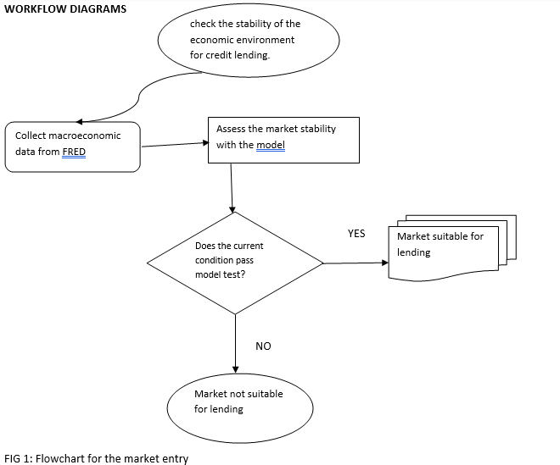

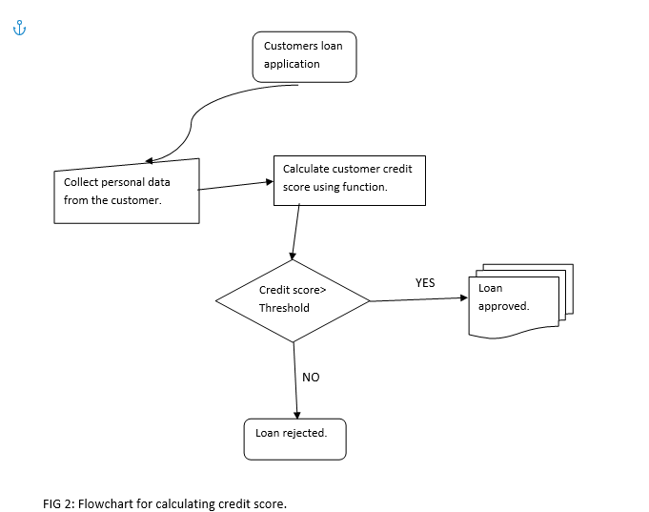

**Risk Management Assessment for Market Entry and Credit Score Calculation**

Introduction

In the credit card lending industry, we perform risk management assessments for market entry and credit scoring. To help the finance team make decisions, we created two Python functions. The first function determines whether entering the credit card lending business is appropriate based on macroeconomic considerations, and the second function determines the credit rating of the potential borrower.

1. Market Assessment

To consider whether it is appropriate to engage in the credit card lending business, the market assessment function evaluates macroeconomic indicators such as inflation rate and unemployment rate. It gives a simple binary answer as to whether current market conditions are favorable or not. However, more indicators and external data sources should be used in in-depth market research. Market assessment risks include:

A. Data quality:

Accurate and timely macroeconomic data is essential to making informed market entry decisions. Using outdated or unreliable data can lead to misjudgment of market conditions.

B. The incomplete picture:

Market complexity may not be fully captured by a small set of macroeconomic indicators. To fully understand the potential risks and opportunities, further examination is necessary.

C. Market Volatility:

The viability of market penetration tactics can be affected by rapid changes in market circumstances and macroeconomic indicators.

Best Practices:

● To get a complete picture of market circumstances, use a variety of macroeconomic indicators.

● Utilize historical data to examine previous market changes and determine how they affected the credit card lending industry.

● Macroeconomic considerations should be continuously monitored, and the assessment should be updated periodically to reflect shifting market conditions.

2. Credit Score Calculation

The function used to calculate credit scores accepts a number of input parameters, including debt-to-income ratio, income, and credit history. It then uses a basic scoring algorithm to generate a credit score. Please note that this is a simplified version, and in real-life situations, more complex and informative models will be used to generate an accurate credit score. Here are the risks involved in calculating credit scores:

A. Data quality:

To produce an accurate credit score, input data must be complete and accurate. The risk to the lending process is due to inaccurate or missing data, which can lead to inaccurate credit assessments.

B. Model Accuracy:

The simplicity of the current model may not fully explain all relevant aspects that influence solvency. To reduce credit scoring errors, more complex models need to be deployed along with continuous validation.

C. Ethical Considerations:

It is important to ensure the ethical collection and use of personal data. To protect sensitive customer information, appropriate data protection and authorization procedures must be in place.

Best practices:

● Regularly review and revise credit scoring models to incorporate new risk factors and improve accuracy.

● To ensure the accuracy and reliability of your data, implement data cleaning and validation processes.

● Comply with data privacy laws and obtain explicit consent from customers before using their information for credit scoring.

Conclusion

Adding market analysis and credit scoring capabilities will improve the finance team's  strategic decision-making ability while minimizing potential risk. However, to ensure the reliability and accuracy of the assessment process, continuous improvement, data quality control and ethical considerations are important. Finance teams can easily navigate the credit markets and capture profitable opportunities while minimizing potential risks by following best practices and remaining vigilant.

1. **Step 6. Risk Management for security lending scenarios.**
   1. **Student: Yhasreen - AAPL Equity Investment** 
      1. Python Graphical Result on propose AAPL investment strategies.
         1. 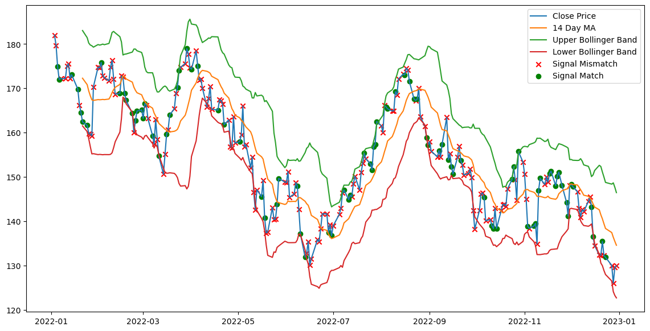
         2. 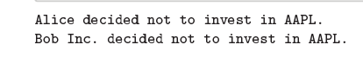
         3. Python code that simulates an AAPL equity investment strategy, encapsulating ethical considerations surrounding data collection based on market sentiment. Market sentiment data is vile with deceptive propaganda propagation and fake news. The proposed investment strategies would encapsulate various stages, from data collection to signal validation and final visualization. This schema can be visually interpreted through a flowchart tool for a more straightforward comprehension.
      2. Workflow diagram on proposed AAPL investment strategies.
         1. This flowchart outlines a step-by-step process through which each investor instance navigates a series of ethical checks for data accuracy and privacy before arriving at an investment decision based on the matching trading signals.
         2. **Step 1.:** Gather AAPL equity price data and market sentiment data.
         3. **Step 2.:** Calculate Technical Indicator
            1. Calculate the 14-day moving average.
            2. Calculate the Relative Strength Index, RSI.
            3. Calculate Bolinger Band
            4. Identify if there is a mismatch between the generated market sentiment signal and the confirmed signal based on technical indicators.
            5. Yes: match confirmation between market sentiment and price movement to invest.
            6. No: mismatch between market sentiment and price movement to invest.
         4. **Step 3.:** Ethical Data Considerations
            1. Data Accuracy Validation

Is the stock price containing any missing or null values?

Yes: Continue

No: Throw error, abort operation

Check if the data retrieved are accurate, as inaccurate data can lead to wrong decisions.

* + - * 1. Data Privacy Restriction

Remove sensitive data such as insider information for unauthorized investors.

The removal process ensures that only authorized personnel can access sensitive or insider information.

* + - * 1. Information Symmetry

Is sensitive information accessible only to authorized investors?

Yes: Continue

No: Throw error, abort operation

Sensitivity accessibility ensures that insider information is not unfairly provided to one type of investor, maintaining a level playing field.

* + - 1. **Step 4.:** Make final investment decision by signal matching identification and ethical checks.
         1. Print the algorithm’s final decision AAPL equity investment.
    1. Apple Equity Investment Risk Management Summary
       1. The increasing ubiquity of digital platforms has engendered novel conduits for market manipulation, especially in the form of propagated propaganda and faux reviews. In AAPL equity trading, this virulent influx of spurious information can imperil the integrity of investment strategies and engender volatility. **Unscrupulous entities often exploit social media and tweets to disperse market sentiment**, artificially inflating the stock value or driving it down through mass hysteria. Exploitation constitutes an exclusivity category of market externality that could have cataclysmic ramifications on individual and institutional investors.
       2. The gravity of this issue is heightened by the considerable influence of Apple Inc. in the financial markets. Given its market capitalization and trading volume, even **marginal shifts in market sentiment can translate into seismic swings in stock valuation**. Therefore, the mitigation of misleading informational inputs becomes imperative for risk management.
       3. **Technical indicators** offer an elegant, though not infallible, counterpoint to this maelstrom of informational ambiguity. The power of these indices lies in their ability to distil the multifaceted, sometimes contradictory data into digestible, quantifiable metrics. Metrics such as the Relative Strength Index, RSI, Moving Average Convergence Divergence, MACD, trading volume, Bollinger Bands, and 14-day moving averages provide a more sterile view of stock value, **insulated from the emotional reactivity of market sentiment.**
       4. **The RSI**, which measures the speed and change of price movements, can be instrumental in identifying 'overbought' or 'oversold' conditions. When propagandistic maneuvers drive a stock into overbought territory, the RSI may serve as an early warning system.
       5. **The Bollinger bands**, another tool that employs a moving average and two standard deviation lines, can help identify price level resistances and supports. A tweet claiming a bullish future for AAPL may temporarily drive-up trading volumes and prices, but the Bollinger Bands could reveal that the stock is trading much higher than its actual value. Bollinger Band offers investors a statistical safeguard against the whims of market sentiment manipulated by fake reviews or tweets.
       6. However, it is pivotal to understand that **these technical indicators are not panaceas.** They function best as components of a diversified risk mitigation strategy. When aligned with other risk-assessment mechanisms like fundamental analysis or algorithmic trading strategies designed to filter out 'noise,' technical indicators can act as effective bulwarks against the vulnerabilities introduced by propaganda and misleading reviews.
  1. **Student: Ebenezer - Illiquid Security Investment** 
     1. Python Result

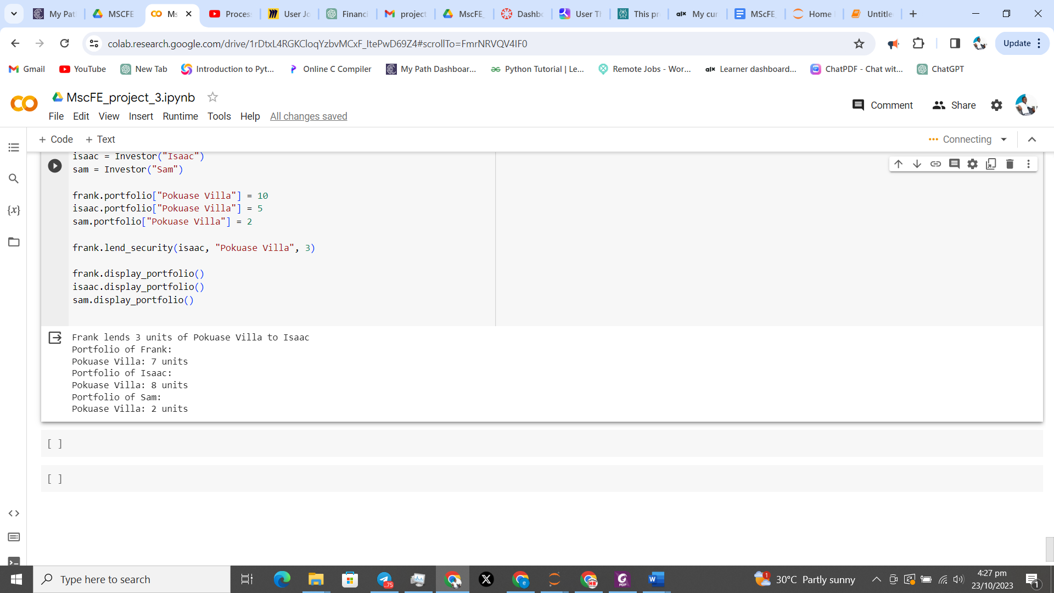

* + 1. Workflow diagram

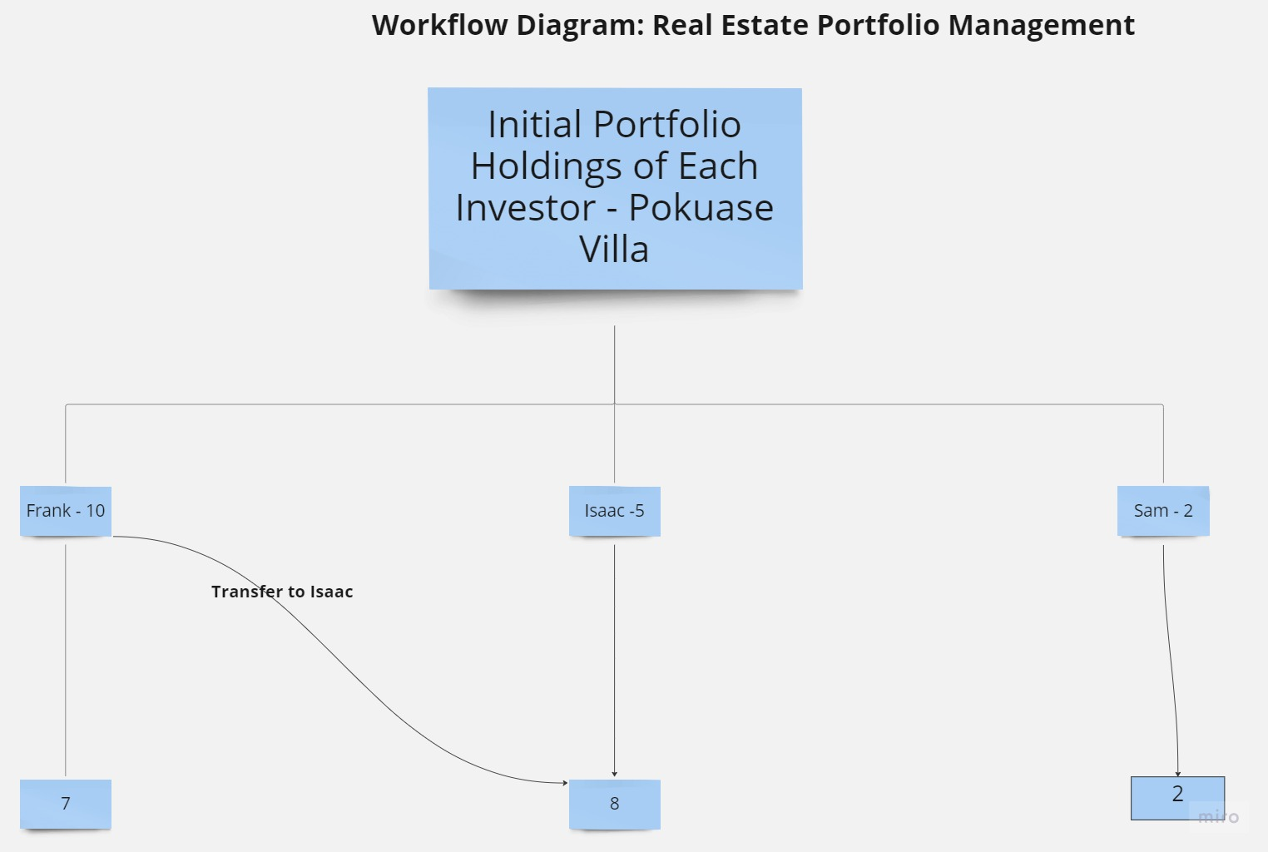

* + 1. Risk Management Summary
* Portfolio Diversification:

Risk Profile Analysis: One of the primary steps in risk management is analyzing the risk profile of the investment portfolio. This includes assessing the type of real estate assets, their locations, market conditions, and historical performance. It is essential to diversify the portfolio to reduce concentration risk. A diversified portfolio helps mitigate the risk associated with fluctuations in specific property values or local real estate market downturns.

* Due Diligence and Asset Valuation:

In-depth Research: Before lending or borrowing illiquid securities like real estate properties, thorough due diligence is essential. This involves researching the property's historical and projected performance, market trends, legal status, and any potential liabilities. Proper valuation helps ensure that assets are exchanged at fair market value.

* Risk Assessment:

Borrower Assessment: For lending scenarios, risk assessment includes evaluating the borrower's creditworthiness and financial stability. It's essential to assess the borrower's ability to maintain and manage the asset. In this case, assessing Isaac's ability to manage the "Pokuase Villa" is critical to risk management.

* Contractual Safeguards:

Smart Contracts: The use of smart contracts provides a secure and automated way to facilitate lending and borrowing transactions. These contracts can include predefined conditions and penalties, helping to mitigate the risk of defaults or breaches of contract.

* Ongoing Monitoring:

Performance Tracking: After the lending or borrowing transaction is executed, continuous monitoring of the asset's performance and market conditions is crucial. Early detection of any issues or deviations from expected outcomes allows for proactive risk management.

* Risk Mitigation Strategies:

Risk Mitigation Funds: A portion of the investment capital can be set aside in a risk mitigation fund. This fund serves as a financial cushion in case of unforeseen events, helping to cover unexpected costs or losses.

Insurance Policies: Depending on the nature of the investment, relevant insurance policies can be acquired to protect against certain risks, such as property damage or liability claims.

* Regulatory Compliance:

Adherence to Regulations: Compliance with real estate and financial regulations is essential. It helps mitigate legal and regulatory risks associated with property transactions.

* Scenario Analysis:

Stress Testing: Conducting stress tests and scenario analyses helps identify vulnerabilities in the portfolio. By simulating adverse market conditions, potential risks can be quantified and strategies for risk mitigation can be developed.

The management of risks associated with real estate investments involves a combination of prudent risk assessment, asset diversification, due diligence, contractual safeguards, and continuous monitoring. Proactive risk mitigation strategies and adherence to regulations play a vital role in maintaining the stability and security of the investment portfolio. By following these risk management practices, the risk management team ensures the safeguarding of investments in the real estate market.

1. **Reference:**
   1. **For Card, Car, Home Loan**
      1. WorldQuant University (2023). Financial Data [Module 7]. Retrieved from https://learn.wqu.edu/my-path/courses/financial-data/modules/m-7-integrating-ethics-a nd-critical-thinking-with-financial-data/tasks/lesson-4-ethical-practices-with-data-lessonnotes
      2. OpenAI. (2022). ChatGPT [Large language model]. <https://chat.openai.com/chat>
      3. Freddie Mac, 30-Year Fixed Rate Mortgage Average in the United States [MORTGAGE30US], retrieved from FRED, Federal Reserve Bank of St. Louis; https://fred.stlouisfed.org/series/MORTGAGE30US, July 25, 2023.
      4. U.S. Bureau of Labor Statistics, Unemployment Rate [UNRATE], retrieved from FRED, Federal Reserve Bank of St. Louis; https://fred.stlouisfed.org/series/UNRATE, July 25, 2023.
      5. World Bank, Inflation, consumer prices for the United States [FPCPITOTLZGUSA], retrieved from FRED, Federal Reserve Bank of St. Louis; https://fred.stlouisfed.org/series/FPCPITOTLZGUSA, July 25, 2023.
      6. U.S. Bureau of Economic Analysis, Gross Domestic Product [GDP], retrieved from FRED,

Federal Reserve Bank of St. Louis; https://fred.stlouisfed.org/series/GDP, July 25, 2023.

* 1. **Student: Yhasreen for Equity & bond**
     1. **Equity**
     2. What is the Hindenburg Research, and what did it report on the Adani Group?

https://www.jagranjosh.com/general-knowledge/what-is-the-hindenburg-research-and-what-did-it-report-on-the-adani-group-1674659241-1

* + 1. Is There Truth in Muddy Waters’ Report on Olam?

<https://www.cnbc.com/id/49988091>

* + 1. Board of Governor of the Federal Reserve system. Volcker Rule.

<https://www.federalreserve.gov/supervisionreg/volcker-rule.htm>

* + 1. Asian Financial Crisis. Between July 1997 and Dec 1998.

https://www.federalreservehistory.org/essays/asian-financial-crisis

* + 1. **Bond**
    2. The 2007–2009 Financial Crisis: An Erosion of Ethics: A Case Study

<https://link.springer.com/article/10.1007/s10551-016-3052-7>

* + 1. The Great Recession and Its Aftermath

<https://www.federalreservehistory.org/essays/great-recession-and-its-aftermath>

* + 1. Fiduciary Duties of Investment Intermediaries

<https://www.lawcom.gov.uk/project/fiduciary-duties-of-investment-intermediaries/>

* + 1. Dodd-Frank Act

https://www.cftc.gov/LawRegulation/DoddFrankAct/index.htm